Activity 9 Documentation Oct 13, 2025
Website 80% zoom
Favorite Pokemons: Eevee and its Evolutions
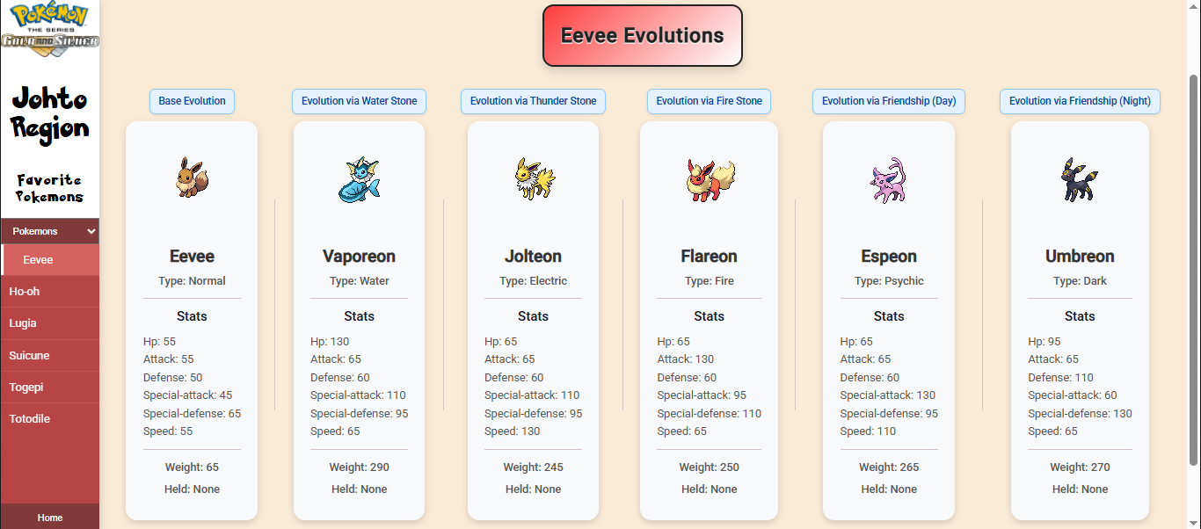
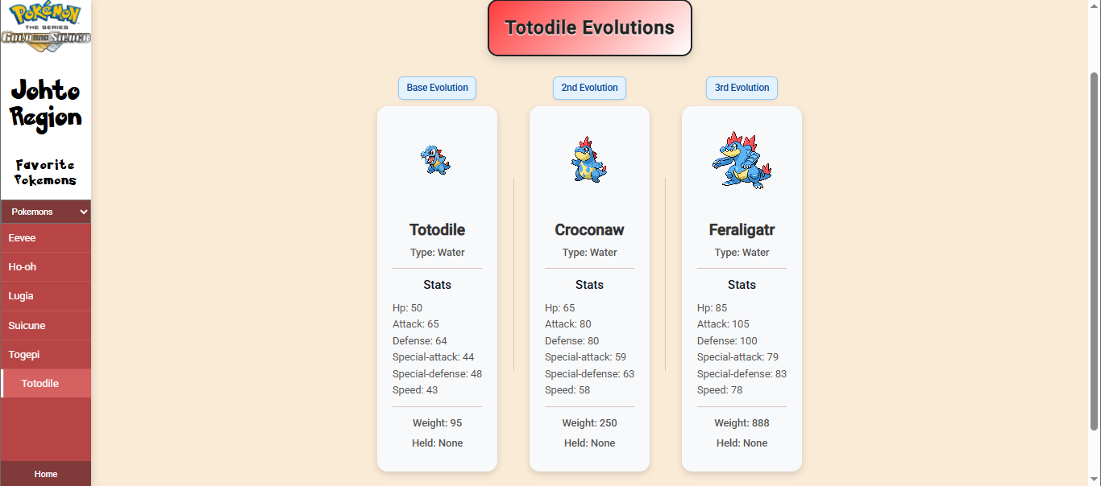
HTML for child-components
<div class="pokemon-card">
<img [src]="pokemon.sprites.front_default" alt="pokemon sprite" />
<h1>{{ pokemon.name | titlecase }}</h1>
<p>Type: {{ pokemon.types[0].type.name | titlecase }}</p>

<mat-divider></mat-divider>

<h3>Stats</h3>
<ul>
@for (item of pokemon.stats; track item.id) {
<li>{{ item.stat.name | titlecase }}: {{ item.base_stat }}</li>
}
</ul>

<mat-divider></mat-divider>

<p>Weight: {{ pokemon.weight }}</p>

@if (!pokemon.held_items || pokemon.held_items.length === 0) {
<p>Held: None</p>
} @else {
<p>Held: {{ pokemon.held_items[0].item.name | titlecase }}</p>
}
</div>
Sample HTML for parent component
<div class="favorite-pokemon-container">
<div class="favorite-pokemon-container-hero">
<h1>Eevee Evolutions</h1>
</div>

<div class="evolution-line">

<div class="evo-wrapper">
<div class="evo-label">Base Evolution</div>
<app-evo0></app-evo0>
</div>

<mat-divider vertical></mat-divider>

<div class="evo-wrapper">
<div class="evo-label">Evolution via Water Stone</div>
<app-evo1-a></app-evo1-a>
</div>

<mat-divider vertical></mat-divider>

<div class="evo-wrapper">
<div class="evo-label">Evolution via Thunder Stone</div>
<app-evo1-b></app-evo1-b>
</div>

<mat-divider vertical></mat-divider>

<div class="evo-wrapper">
<div class="evo-label">Evolution via Fire Stone</div>
<app-evo1-c></app-evo1-c>
</div>

<mat-divider vertical></mat-divider>

<div class="evo-wrapper">
<div class="evo-label">Evolution via Friendship (Day)</div>
<app-evo1-d></app-evo1-d>
</div>

<mat-divider vertical></mat-divider>

<div class="evo-wrapper">
<div class="evo-label">Evolution via Friendship (Night)</div>
<app-evo1-e></app-evo1-e>
</div>

</div>
</div>

